Multiple Choice Questions

1) Which of the following bases is found only in DNA?

A) adenine
B) thymine
C) uracil
D) cytosine
E) guanine

Answer: B

Difficulty: 1 Topic: The Nature of Nucleic Acids

2) Which of the following is correctly paired?

A) adenine: pyrimidine
B) RNA: ribose containing nucleic acid
C) thymine: purine
D) uracil: purine
E) DNA: ribose containing nucleic acid

Answer: B

Difficulty: 1 Topic: The Nature of Nucleic Acids

3) Which of the following correctly describes the structure of a nucleotide?

A) adenine is bound via a link between N-7 and C-1 of ribose
B) phosphates are always bound to C-2 of ribose
C) cytosine is bound via a link between the amine on C-4 and C-1 of ribose
D) guanine is bound via a link between N-9 and C-1 of ribose
E) none of the above

Answer: D

Difficulty: 2 Topic: The Nature of Nucleic Acids

4) Which of the following is correctly paired with the type of tautomerization(s) that occurs?

A) adenine: keto-enol
B) cytosine: amino-imino and keto-enol
C) guanine: amino-imino
D) thymine: keto-enol
E) none of the above

Answer: D

Difficulty: 2 Topic: The Nature of Nucleic Acids

5) Based on the following, what can be said about the synthesis of polynucleotides?
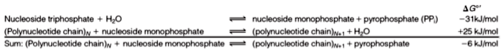
A) polynucleotides are unstable and are rapidly degraded
B) polynucleotide formation is made much more exergonic by the hydrolysis of pyrophosphate
C) the hydrolysis of nucleoside triphosphates is the only driving force to make an overall irreversible reaction
D) polynucleotides are highly resistant to hydrolysis, even in the presence of an acid catalyst
E) none of the above

Answer: B

Difficulty: 2 Topic: The Nature of Nucleic Acids

6) Which of the following describes the directionality seen in nucleic acids?

A) most polynucleotides have an unreacted 5′ hydroxyl group
B) all polynucleotides have an unreacted 2′ hydroxyl group
C) most polynucleotides have a phosphate group on the 5′ end
D) sequences of polynucleotides are generally written from 3′ on the left to 5′ on the right
E) none of the above

Answer: C

Difficulty: 1 Topic: Primary Structure of Nucleic Acids

7) Based on the following, which is true regarding the acid/base properties of guanine?
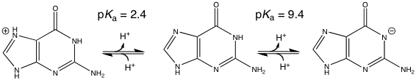
A) at physiological pH, guanine will be positively charged
B) at physiological pH, guanine will be negatively charged
C) at physiological pH, guanine will be neutral
D) at physiological pH, guanine will be a very effective buffer against base
E) at physiological pH, guanine will be a very effective buffer against acid

Answer: C

Difficulty: 2 Topic: The Nature of Nucleic Acids

8) From the following polynucleotide sequence, one would conclude which of the following?
ACCAGTCG
A) the base found at the 3′ end of the molecule is adenine
B) the base found at the 5′ end of the molecule is adenine
C) the terminal adenosine contains a free 3′ hydroxyl group
D) the terminal guanosine contains a free 5′ phosphate group
E) none of the above

Answer: B

Difficulty: 2 Topic: Primary Structure of Nucleic Acids

9) Which of the following techniques was used to determine the double helical structure of DNA?

A) NMR spectroscopy
B) X-ray diffraction
C) Raman spectroscopy
D) UV/Vis spectroscopy
E) IR spectroscopy

Answer: B

Difficulty: 1 Topic: Secondary and Tertiary Structure of Nucleic Acids

10) Which of the following base pairs would have 2 hydrogen bonds and a distance between C-1′ of 1.08 nm?

A) A-C
B) G-C
C) A-T
D) G-T
E) none of the above

Answer: C

Difficulty: 1 Topic: Secondary and Tertiary Structure of Nucleic Acids

11) Base stacking, or the “stacking interaction,” is most likely the result of which noncovalent interaction

A) charge-dipole interaction
B) dipole-dipole interaction
C) dipole-induced dipole interaction
D) van der Waals interaction
E) none of the above

Answer: D

Difficulty: 2 Topic: Secondary and Tertiary Structure of Nucleic Acids

12) In the Watson-Crick DNA model, how many base pairs are found in one turn of the helix?

A) 4
B) 6
C) 8
D) 10
E) 12

Answer: D

Difficulty: 1 Topic: Secondary and Tertiary Structure of Nucleic Acids

13) Replication of DNA is best considered __________.

A) conservative
B) semiconservative
C) dispersive
D) complementary
E) none of the above

Answer: B

Difficulty: 1 Topic: Secondary and Tertiary Structure of Nucleic Acids

14) Which of the following best explains why the ratios of A/T and G/C are 0.77 and 1.08, respectively in bacteriophage φX174?

A) the base pairing in bacteriophages is not always A-T and C-G
B) studies done with most bacteriophages do not use complete genomic DNA due to the inherent instability of phage DNA
C) bacteriophage DNA often uses bases other than A, T, C and G
D) many viruses often use single stranded DNA
E) none of the above

Answer: D

Difficulty: 2 Topic: Secondary and Tertiary Structure of Nucleic Acids

15) Which of the following is a major difference between B-DNA and A-DNA?

A) B-DNA has a right-handed helix, A-DNA has a left-handed helix
B) B-DNA has 10 residues per helix turn while A-DNA has 9
C) B-DNA base pairs are stacked almost parallel to one another while A-DNA base pairs are significantly tilted with respect to each other
D) the major groove of A-DNA is much larger than that in B-DNA
E) none of the above

Answer: C

Difficulty: 2 Topic: Secondary and Tertiary Structure of Nucleic Acids

16) Which of the following types of DNA are often supercoiled?

A) extremely long linear DNA, such as seen in human chromosomes
B) very short linear DNA
C) circular DNA
D) DNA molecules that contain both circular and linear regions
E) all of the above

Answer: C

Difficulty: 1 Topic: Secondary and Tertiary Structure of Nucleic Acids

17) While RNA is often single stranded, transfer RNA (tRNA) is usually found with some double stranded structure. Which of the following explains this?

A) tRNAs contain self-complimentary stem-loop structures
B) after synthesis, tRNA molecules are hydrolyzed in specific places to allow double stranded structures to form
C) regions of tRNAs become supercoiled, thus forcing formation of double stranded regions
D) tRNAs adopt a form much like Z-DNA allowing double stranded regions to form
E) none of the above

Answer: A

Difficulty: 2 Topic: Secondary and Tertiary Structure of Nucleic Acids

18) Which of the following is correct regarding the flow of genetic information?

A) replication uses a DNA template to form RNA which serves as the new template for DNA synthesis
B) transcription produces RNA from a DNA template using the enzyme RNA polymerase
C) translation uses mRNA as a template, rRNA to carry amino acids, and tRNA to catalyze the synthesis of proteins
D) during both replication and transcription, the products are double stranded polynucleotides
E) none of the above

Answer: B

Difficulty: 1 Topic: The Biological Functions of Nucleic Acids

19) Which of the following is the most commonly observed nucleic acid form for storing of genomic information?

A) single-stranded DNA
B) double-stranded DNA
C) single-stranded RNA
D) double-stranded RNA
E) hybrid molecules of DNA and RNA

Answer: B

Difficulty: 1 Topic: The Biological Functions of Nucleic Acids

20) In a circular DNA molecule of 126 bp with 10.5 bp/turn, which of the following represents an unstrained circle? (L = linking number, T = twist and W = writhe)

A) L = 12, T = 12, W = 0
B) L = 11, T = 11, W = 0
C) L = 11, T = 12, W = -1
D) L = 12, T = 11, W = +1
E) L = 11, T = 10, W = 0

Answer: A

Difficulty: 3 Topic: Plasticity of Secondary and Tertiary DNA Structure

21) The following shows deoxyadenosine in the _____ conformation
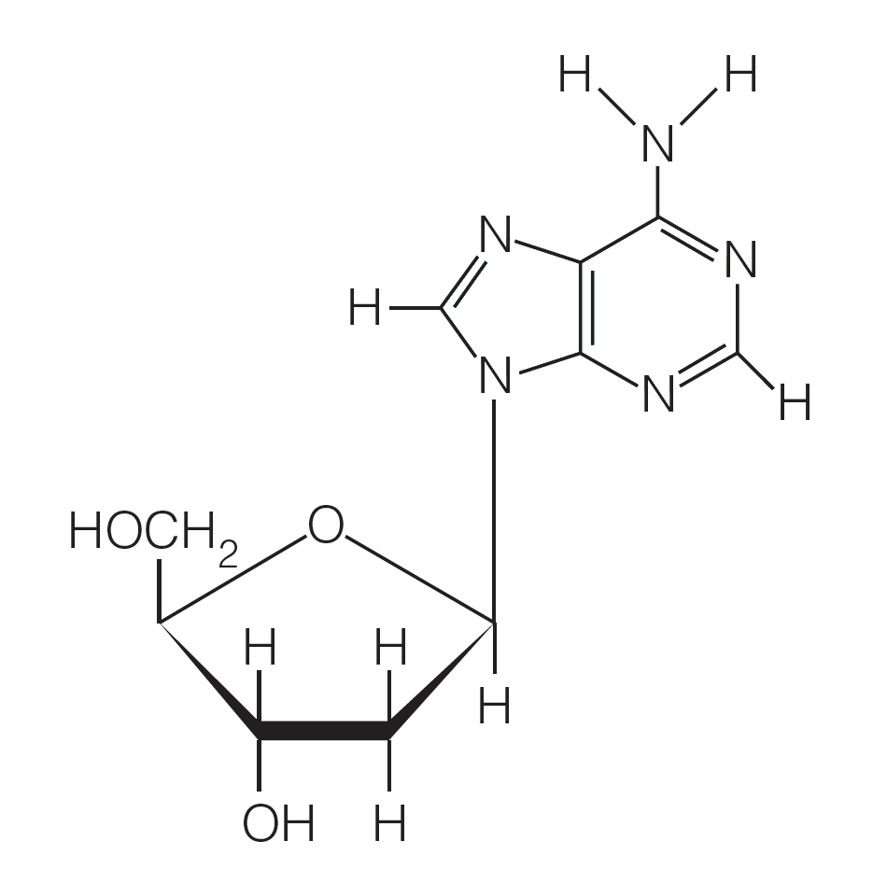
A) syn
B) anti
C) cis
D) trans
E) none of the above

Answer: B

Difficulty: 1 Topic: Plasticity of Secondary and Tertiary DNA Structure

22) Which of the following represents a palindromic sequence?

A) ACCTTCCA
B) ATTCCAAT
C) GATTAATC
D) GGTAATCC
E) none of the above

Answer: C

Difficulty: 1 Topic: Plasticity of Secondary and Tertiary DNA Structure

23) Which of the following secondary structures is correctly identified?

A) Z-DNA: left-handed DNA with pyrimidines in the syn conformation and purines in the anti conformation
B) hairpin structure: self-complimentary single stranded molecules that form a parallel helix
C) cruciform: a double hairpin formed in a region of palindromic DNA
D) H-DNA: triple helical structure that results when Watson-Crick base pairing does not form and instead, Hoogsteen base pairing occurs
E) none of the above

Answer: C

Difficulty: 2 Topic: Plasticity of Secondary and Tertiary DNA Structure

24) Where are G-quadruplexes most commonly found?

A) transcription termination sites
B) origin of replication
C) the ends of hairpin loops
D) telomeres
E) none of the above

Answer: D

Difficulty: 2 Topic: Plasticity of Secondary and Tertiary DNA Structure

25) Which of the following, when paired with its complementary strand, would have the highest T_{m}?

A) AAGTTCCAGT
B) GCAGCAGCAT
C) ATTACGAGCT
D) GCGAAATCAA
E) TGACCTTGAA

Answer: B

Difficulty: 2 Topic: Stability of Secondary and Tertiary Structure

Short Answer Questions

1) Draw the structure of cytosine and thymine, then show the most common tautomer of each.

Answer:
Cytosine: Thymine:
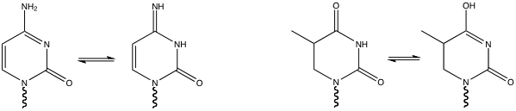

Difficulty: 2 Topic: The Nature of Nucleic Acids

2) Show the typical hydrogen bonds that from when adenine pairs with its complimentary base.

Answer:

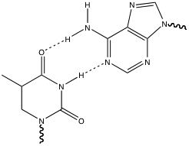

Difficulty: 2 Topic: Secondary and Tertiary Structure of Nucleic Acids

3) Draw the two forms of a phosphodiester bond that can occur under physiological pH. If the pK_{a} for this conversion is 6.2, what form predominates in the lysosome where the pH is about 5?

Answer:

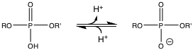

The protonated form on the left would predominate in the lysosome

Difficulty: 2 Topic: The Nature of Nucleic Acids

